
press release
(English translation)

ENADA PRIMAVERA OPENS TODAY: THE WORLD OF GAMING AND AMUSEMENT
UNDER ONE ROOF AT RIMINI EXPO CENTRE

At the opening ceremony of the 37th edition, IEG President Maurizio Ermeti welcomed EUROMAT President Jason Frost, SAPAR President Domenico Distante, ADM Entertainment Equipment Director Elisabetta Poso,
and Rimini City Councillor Francesco Bragagni.

Rimini (Italy), 17 February 2025 – This morning saw the inauguration of the 37th edition of Enada Primavera, the Italian Exhibition Group (IEG) event dedicated to the gaming and amusement industry. The event was promoted by SAPAR (National Association of State Gaming Managers).
Running till Wednesday February 19, the international network of gaming equipment and systems will fill the halls of Rimini Expo Centre. The event aims to foster business opportunities between professional operators and companies, both Italian and foreign. Compared to the previous edition, the number of foreign companies has doubled, hailing from China, Cyprus, Israel, Malta, Germany, the United Kingdom, Spain, and Taiwan. These companies are leaders in the production of physical media, technologies, spare parts, and services for land-based gaming, payment and security systems, and software for online gaming.

At the same time, the 7th edition of RAS - Rimini Amusement Show is taking place in a designated hall. This section is dedicated to non-cash entertainment, creating a marketplace of reference in Southern Europe and the Mediterranean area for the entire industry within the IEG expo venue.

THE RIBBON-CUTTING CEREMONY IN THE VISION ARENA
Enada Primavera 2025 kicked off on the Vision Arena stage, with the event moderated by AGIMEG's managing director, Fabio Felici. IEG's president, Maurizio Ermeti, delivered the opening greeting: “Enada, and Rimini Amusement Show, have found the ideal location at Rimini Expo Centre to grow and develop, becoming a strategic business platform for Italy, Europe, and the rest of the world”.

As always, we're proud to be here at Enada Primavera," commented SAPAR President Domenico Distante. “Today, we inaugurate this trade show, fully aware of the challenges facing our industry. However, we remain optimistic about the potential for continuous improvement, working alongside institutions to safeguard both players and the entire supply chain”.

“Rimini is thrilled to welcome all those who have chosen this destination, including those from faraway lands, thanks to Enada”, added Francesco Bragagni, the councillor for human resources development, civic services, toponymy, legality, and relations with the Rimini municipal council. “Rimini is a city that has successfully reinvented itself, broadened its horizons, and seized every opportunity, always looking to the future”.

“Our participation in this significant industry event highlights the importance of supporting the legal gaming industry, which serves as the State's operational arm in the region through the concession system. This ensures safe gaming, respect for the rules, and a focus on the health of citizens," added Elisabetta Poso, Director of the Entertainment Devices Office at the Customs and Monopolies Agency.

Jason Frost, President of EUROMAT European Gaming & Amusement Federation, emphasised that “innovation also involves regulating and safeguarding legal gaming. Clear and proportionate regulation enables investment and user protection”.

THE PRESENTATION OF THE LORENZO CAGNONI AWARDS AND THE FIRST SCHEDULED EVENTS
Following the opening ceremony, the ‘Lorenzo Cagnoni Awards’ were presented, along with the Innovation District awards. This project, organised in partnership with ANGI (National Association of Young Innovators), recognises the best innovations showcased at the event and the top startups offering technologies, services, and solutions for the gaming and amusement industry. SEMNOX SOLUTIONS LIMITED, ASSIMOX Money Mox, and REVOLT and BLASTER FOUNDRY were recognised for their outstanding achievements, with the latter two receiving the prestigious best start-up awards.

In the afternoon, the Vision Arena stage hosted the SAPAR-curated conference, which focused on market data and the current state of public gaming in Italy.

Today and tomorrow will see the partial overlap with the 10th edition of Beer&Food Attraction, IEG's Eating Out Experience Show, which focuses on the world of eating out. This event offers the public of Enada Primavera and especially Rimini Amusement Show new opportunities and business exchanges, given the shared interest in public establishments.

ABOUT ENADA 2025
Date: 17-19 February 2025; Organiser: Italian Exhibition Group S.p.A., in collaboration with SAPAR; edition: 37th; recurrence: annual; info: https://www.enada.it/

ABOUT RAS 2025
Date: 17-19 February 2025; Organiser: Italian Exhibition Group S.p.A., in collaboration with SAPAR; edition: 7th; recurrence: annual; info: https://www.riminiamusement.it/

PRESS CONTACT ITALIAN EXHIBITION GROUP
head of media relation & corporate communication: Elisabetta Vitali; press office manager: Marco Forcellini, Pier Francesco Bellini; international press office coordinator: Silvia Giorgi; press office coordinator: Luca Paganin; press office specialist: Nicoletta Evangelisti, Mirko Malgieri: media@iegexpo.it

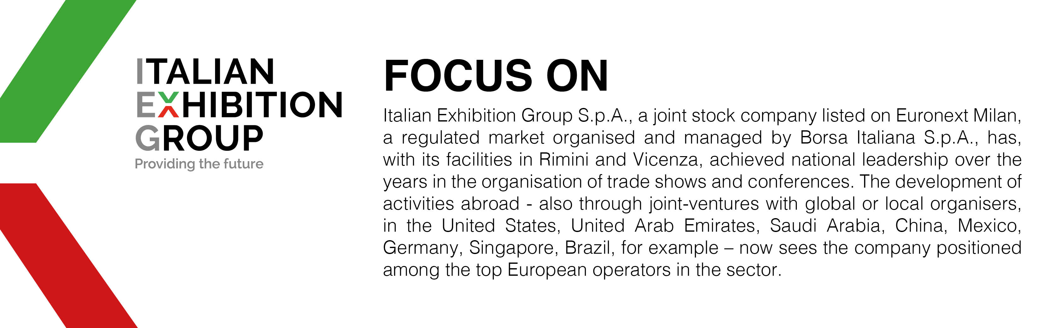

This press release contains forecast elements and estimates that reflect the management’s current opinions (“forward-looking statements”), particularly regarding future management performance, realization of investments, cash flow trends and the evolution of the financial structure. For their very nature, forward-looking statements have a component of risk and uncertainty, as they depend on the occurrence of future events. The effective results may differ (even significantly) from those announced, due to numerous factors, including, only by way of example: food service market and tourist flow trends in Italy, gold and jewellery market trends, green economy market trends; the evolution of raw material prices; general macroeconomic conditions; geopolitical factors and evolutions in the legislative framework. Moreover, the information contained in this release does not claim to be complete, and has not been verified by independent third parties. Forecasts, estimates and objectives contained herein are based on the information available to the Company as at the date of this release.

